10.39: a) The net force is due to the tension in the rope, which always acts in the radial direction, so the angular momentum with respect to the hole is constant.
b) 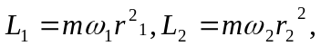and with 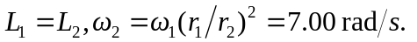
c)
d) No other force does work, so 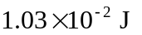 of work were done in pulling the cord.

